**Mathematical Concepts**

**Content**

1. **Vectors**
2. **Differentiation**
3. **Partial Differentiation**
4. **Gradient**
5. **Maxima and Minima**

**VECTORS**

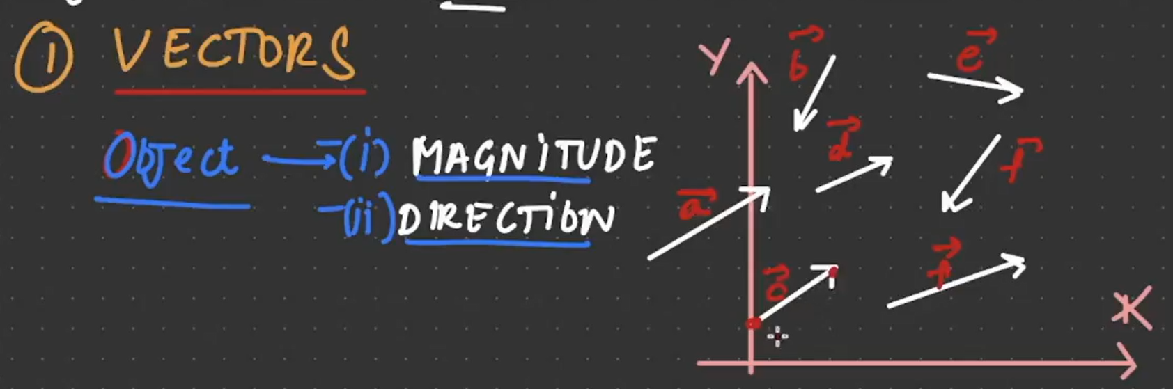

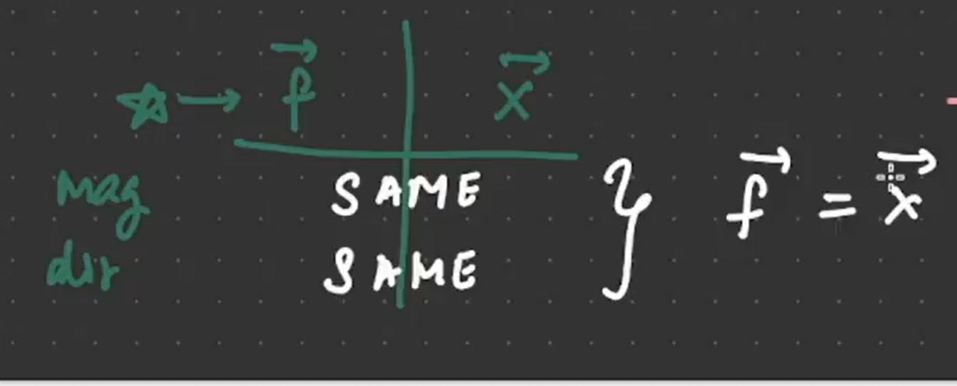

**DIFFERENTIATION**

